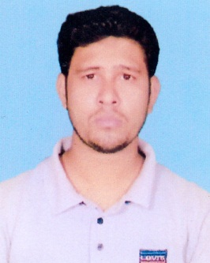

**CURRICULUM VITAE**

**OF**

**MD. BORHANUR RAHMAN**

* **Mailing Address:**

Village: Mominnagar, P.O: Gorai,

P.S: Mirzapur, Dist: Tangail

Cell: +8801741530482

* **Career Objective:**

Intend to work in challenging competitive environment where strong sense of responsibility and commitment is required. Where dignity of work provides job satisfaction and place of work provides potential avenues for learning, growing and achieving the hierarchy of the organization.

* **Education Background:**

**(B.A) (Bachelors of Arts Studies):**

Institution : Shaghata Degree College.

Group : B.A

Result : 2.90

Board : National University

**H.S.C (Higher Secondary Certificate) :**

Institution : Police Lines School & College.

Group : Humanities

Result : G.P.A- 3.20

Board : Rajshahi

Passing Year : 2014

**S.S.C (Secondary School Certificate) :**

Institution : Jumarbari High School

Group : Humanities

Result : G.P.A- 3.25

Board : Dinajpur

Passing Year : 2012

* **Hobby:**

Reading, Books, Sports, Newspaper, Traveling and Consulting.

* **Language:**

Bangle : Fluent in both speaking and writing.

English : Medium in both speaking and writing.

* **Key Strength:**

Ability to learn new things very quickly and to maintain good relation with others, capability of working under pressure and meeting deadlines, taking any decision instance, honesty, having the organizing and motivating power.

* **Experience:**

Institution Name : **Birds Group**

Designation : Storekeeper

Duration : 2 Years

Address : Mominnagar, Gorai, Tangail.

Institution Name : **I R Khan Jute Miles Ltd.**

Designation : Driver

Duration : 2 Years

Address : Bormi, Sreepur, Gazipur.

* **Personal Details:**

Name : Md. Borhanur Rahman

Father’s Name : Md. Ohidul Alam

Mother’s Name : Most. Bizly Akter

Date of Birth : 25/01/1997

Permanent Address : Village: Chandpara, PO: Jumarbari,

P.S: Shaghata, Dist: Gaibandha.

Gender : Male

Marital Status : Married

Height : 5' 4”

Weight : 60 Kg

Blood Group : A- (Negative)

Nationality : Bangladeshi (by birth)

* **Reference:**

Name : Md. Foridul Islam

Cell : +88 01713710800

* **Declaration:**

I hereby declare that the above mentioned particular and true and correct to the best of my knowledge and belief assuring you my best service always.

**Signature:**

Date: .......................